Community Task & Volunteer Coordination Platform – Documentation (Simplified)

1️⃣ Project Overview
Project Name: Community Task & Volunteer Coordination Platform
Description:
Our platform is a web-based system that connects volunteers with community activities.
The platform allows users to:
- Register a personal account (name, phone, email, password, etc.).
- View a list of available activities for volunteering, including details such as location, date, description, and required number of volunteers.
- Submit a volunteer request for any available activity (VolunteerApplication).
- Providers can submit requests to create new activities that need volunteers (ActivityRequest).
- Admins can manage activities, approve or reject activity requests, and monitor volunteer progress.
Project Importance:
- The platform encourages community engagement and volunteering.
- It provides an effective management system for community activities, especially in Palestine where such platforms are rare.
- It helps increase the number of volunteers and promotes participation in social causes.

2️⃣ Requirements

Functional Requirements
- Register a new user (Volunteer, Provider, or Admin).
- Login authentication and role-based authorization.
- Display available activities to volunteers.
- Submit a volunteer application for any activity.
- Submit a new activity request by providers.
- Manage activity requests (approve or reject by Admin).
- Create official activities after admin approval.
- Track the status of all applications (Pending, Approved, Rejected).
- Display full activity details (Title, Description, Location, Date, Needed Volunteers).
- Allow updating or deleting accounts and activities with automatic timestamp updates.

Non-Functional Requirements
- Responsive Design:
  - The application must work on:
    - Mobile phones
    - Tablets
    - Laptops / Desktops
- Usability / Accessibility:
  - User-friendly for all ages (children, teenagers, adults, seniors).
  - Clear and simple interfaces, readable buttons and text.
  - Smooth navigation between pages.
- Performance:
  - API response time under 2 seconds.
  - Fast loading of activity lists even with many records.
- Security:
  - Passwords stored securely using hashing.
  - JWT-based authentication and authorization for each role.
  - Prevent unauthorized access to APIs.
- Reliability:
  - Accurate data storage with timestamps (created_at, updated_at).
  - Prevent orphaned records using ON DELETE CASCADE where necessary.

3️⃣ Database Entities & Relationships

1. User Table
CREATE TABLE "User" (
user_id SERIAL PRIMARY KEY,
first_name VARCHAR(50) NOT NULL,
last_name VARCHAR(50) NOT NULL,
email VARCHAR(100) UNIQUE NOT NULL,
phone VARCHAR(20),
password VARCHAR(255) NOT NULL,
role user_role DEFAULT 'volunteer',
status user_status DEFAULT 'active',
created_at TIMESTAMP DEFAULT CURRENT_TIMESTAMP,
updated_at TIMESTAMP DEFAULT CURRENT_TIMESTAMP
);
- Providers can create multiple ActivityRequests.
- Volunteers can submit multiple VolunteerApplications for different activities.

2. ActivityRequest Table
CREATE TABLE ActivityRequest (
request_id SERIAL PRIMARY KEY,
provider_id INT NOT NULL,
title VARCHAR(150) NOT NULL,
description TEXT NOT NULL,
location VARCHAR(150) NOT NULL,
activity_date DATE NOT NULL,
needed_volunteers INT NOT NULL CHECK (needed_volunteers > 0),
status request_status DEFAULT 'pending',
created_at TIMESTAMP DEFAULT CURRENT_TIMESTAMP,
updated_at TIMESTAMP DEFAULT CURRENT_TIMESTAMP,
CONSTRAINT fk_provider
FOREIGN KEY (provider_id)
REFERENCES "User"(user_id)
ON DELETE CASCADE
);
- Each ActivityRequest is linked to one Provider.
- A provider can create multiple activity requests.

3. Activity Table
CREATE TABLE Activity (
activity_id SERIAL PRIMARY KEY,
request_id INT UNIQUE NOT NULL,
status activity_status DEFAULT 'open',
created_at TIMESTAMP DEFAULT CURRENT_TIMESTAMP,
CONSTRAINT fk_request
FOREIGN KEY (request_id)
REFERENCES ActivityRequest(request_id)
ON DELETE CASCADE
);
- Each Activity is linked to one ActivityRequest only (1:1).

4. VolunteerApplication Table
CREATE TABLE VolunteerApplication (
application_id SERIAL PRIMARY KEY,
activity_id INT NOT NULL,
volunteer_id INT NOT NULL,
status application_status DEFAULT 'pending',
applied_at TIMESTAMP DEFAULT CURRENT_TIMESTAMP,
CONSTRAINT fk_activity
FOREIGN KEY (activity_id)
REFERENCES Activity(activity_id)
ON DELETE CASCADE,
CONSTRAINT fk_volunteer
FOREIGN KEY (volunteer_id)
REFERENCES "User"(user_id)
ON DELETE CASCADE,
CONSTRAINT unique_application
UNIQUE (activity_id, volunteer_id)
);
- Each VolunteerApplication is linked to one Activity and one Volunteer.
- Volunteers can apply to multiple activities.
- Volunteers cannot apply more than once to the same activity.

5️⃣ Trigger to Update updated_at Automatically
CREATE OR REPLACE FUNCTION update_updated_at_column()
RETURNS TRIGGER AS $$
BEGIN
NEW.updated_at = CURRENT_TIMESTAMP;
RETURN NEW;
END;
$$ language 'plpgsql';

Linking Trigger to Tables:
CREATE TRIGGER update_user_updated_at
BEFORE UPDATE ON "User"
FOR EACH ROW
EXECUTE FUNCTION update_updated_at_column();
CREATE TRIGGER update_request_updated_at
BEFORE UPDATE ON ActivityRequest
FOR EACH ROW
EXECUTE FUNCTION update_updated_at_column();
- Every time a row in User or ActivityRequest is updated → the updated_at column is automatically updated.

1. Users
-- Admin
INSERT INTO "User" (first_name, last_name, email, phone, password, role)
VALUES ('Ahmad', 'Ali', 'ahmad@example.com', '0591234567', 'hashed_pw', 'admin');
-- Volunteer
INSERT INTO "User" (first_name, last_name, email, phone, password, role)
VALUES ('Sara', 'Salem', 'sara@example.com', '0599876543', 'hashed_pw', 'volunteer');
-- Provider
INSERT INTO "User" (first_name, last_name, email, phone, password, role)
VALUES ('Omar', 'Hassan', 'omar@example.com', '0591122334', 'hashed_pw', 'provider');

2. ActivityRequest
INSERT INTO ActivityRequest (provider_id, title, description, location, activity_date, needed_volunteers)
VALUES
(3, 'Beach Cleanup', 'Cleaning the beach area', 'Gaza Beach', '2026-03-10', 20),
(3, 'Tree Planting', 'Planting trees in the park', 'Nablus Park', '2026-03-12', 15);

3. Activity
INSERT INTO Activity (request_id, status)
VALUES (1, 'open'), (2, 'open');

4. VolunteerApplication
-- Sara applies to Beach Cleanup
INSERT INTO VolunteerApplication (activity_id, volunteer_id)
VALUES (1, 2);
-- Another volunteer applies to Tree Planting
INSERT INTO VolunteerApplication (activity_id, volunteer_id)
VALUES (2, 2);

2️⃣ SELECT Examples (Reading Data)

1. All Users
SELECT * FROM "User";
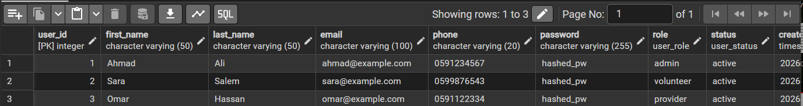

2. All Activities with Request Details (JOIN)
SELECT a.activity_id, ar.title, ar.description, ar.location, ar.activity_date, ar.needed_volunteers, a.status
FROM Activity a
JOIN ActivityRequest ar ON a.request_id = ar.request_id;

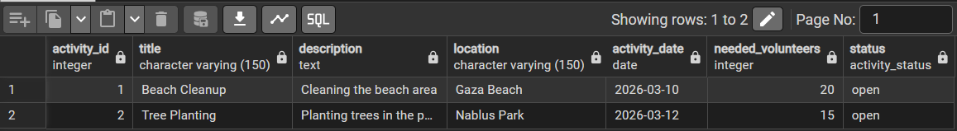

3. Volunteer Applications with Volunteer Name and Activity Title
SELECT va.application_id, u.first_name || ' ' || u.last_name AS volunteer_name, ar.title AS activity_title, va.status, va.applied_at
FROM VolunteerApplication va
JOIN "User" u ON va.volunteer_id = u.user_id
JOIN Activity a ON va.activity_id = a.activity_id
JOIN ActivityRequest ar ON a.request_id = ar.request_id;

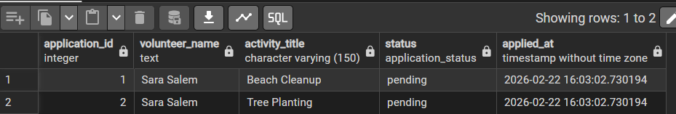

4. Count of Volunteers per Activity
SELECT ar.title AS activity_title, COUNT(va.application_id) AS total_volunteers
FROM VolunteerApplication va
JOIN Activity a ON va.activity_id = a.activity_id
JOIN ActivityRequest ar ON a.request_id = ar.request_id
GROUP BY ar.title;

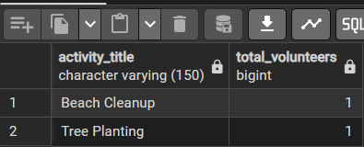

3️⃣ UPDATE Examples

1. Update User Status
UPDATE "User"
SET status = 'suspended', updated_at = CURRENT_TIMESTAMP
WHERE user_id = 2;

2. Update Activity Status
UPDATE Activity
SET status = 'closed'
WHERE activity_id = 1;

3. Approve a Volunteer Application
UPDATE VolunteerApplication
SET status = 'approved'
WHERE application_id = 1;

4️⃣ DELETE Examples

1. Delete a Volunteer Application
DELETE FROM VolunteerApplication
WHERE application_id = 2;

2. Delete an Activity (cascade deletes related VolunteerApplications)
DELETE FROM Activity
WHERE activity_id = 2;

3. Delete a User (cascade deletes related requests & applications)
DELETE FROM "User"
WHERE user_id = 3;

